Annex 1 – Technical specification

TECHNICAL SPECIFICATION

Name of public contract:

DELIVERY OF MOBILE CAMERAS AND PROVISION OF RELATED SERVICES

Above-the-threshold public delivery contract,
open procedure (hereinafter the “Public Contract”)

Reference number: VZ_2019_A48

Public Contract objective

The aim of the Public Contract is to select the most economically advantageous tender for the supply of TCP/IP cameras (hereinafter referred to as the "Goods").

The cameras shall be used to take video sequences of road vehicles during day and night under all normal weather and light conditions.

The cameras will be installed in the vehicles of the so called mobile patrols. The video quality and cameras lifetime must not be negatively affected by shocks and vibrations caused by the normal operation of the road vehicle.

Video sequences from the cameras will be further processed and evaluated by the contracting authority's own information system (hereinafter also referred to as “IS EDAZ”), which will further process meta data, such as for example recognized license plate number, country of registration and make and model (hereinafter referred to as the "control records").

Control records will then be provided to mobile patrols of the Police of the Czech Republic and the Customs Administration of the Czech Republic for inspection of the toll payments of the cars under 3.5t on the toll roads of the Czech Republic.

The cameras shall be mounted and fixed by a swivel bracket either on the horizontal part of the dashboard or on the windscreen of the mobile patrol vehicles, according to the supplier's offer.

The contracting authority requests that the bracket is supplied together with the camera and must allow the mobile patrol crew to easily turn of the camera horizontally and vertically to point to the desired direction according to the specific use case (shooting while standing still, during slow and fast motion, please refer to article 2).

The cameras will be connected with Ethernet cable with PoE injector (i.e. by single power and data cable) to the local processing unit.

The connection will be provided according to the following diagram:

The contracting authority will acquire the cameras via a purchase contract with delivery to a specified destination in the Czech Republic (see Annex 2 to the tender documentation – a binding draft Purchase Contract).

The contracting authority also requests the following services to be part of the performance of the public contract in question:
- training of camera system administrators;
- methodological and technical assistance during installation, commissioning and operation of supplied camera systems;
- warranty repairs / replacements included in the purchase price of cameras.
Note: this request of the contracting authority is based on the results of the PMC (see the reference in paragraph 1.8 of the tender documentation) where the PMC participants, INEL - Market, s.r.o., Company ID: 25223399, CROSS Zlín, a.s., Company ID: 60715286, Macq nv, Company ID: 0402226831 and others have suggested to use a replacement-based warranty repair system.

The contracting authority requires the participant to state in its tender, among other things, the following information about the Goods offered:
- confirmation of the expected cessation of production of the offered camera type; and
- information on the expected post-warranty support period of the equipment that was discontinued or that will be discontinued before the expiry of the warranty period offered by the participant.
Note: this requirement is set by the contracting authority on the recommendation of the PMC participant (see the reference in paragraph 1.8 of the tender documentation), LENIA spol. s r.o., Company ID: 41186176.

Installation, wiring and commissioning of the cameras will be carried out by the contracting authority by its own resources, and at its own expense and risk.

Camera use cases
The contracting authority requires that all the use cases listed below can be realized even with reduced visibility, resp. in night mode without the use of IR illumination.

Standstill shooting
For this use case a max. 70º view angle is required. The mobile patrol vehicle stands still off the road and capture passing vehicles with a focus on the vehicle's license plate area.
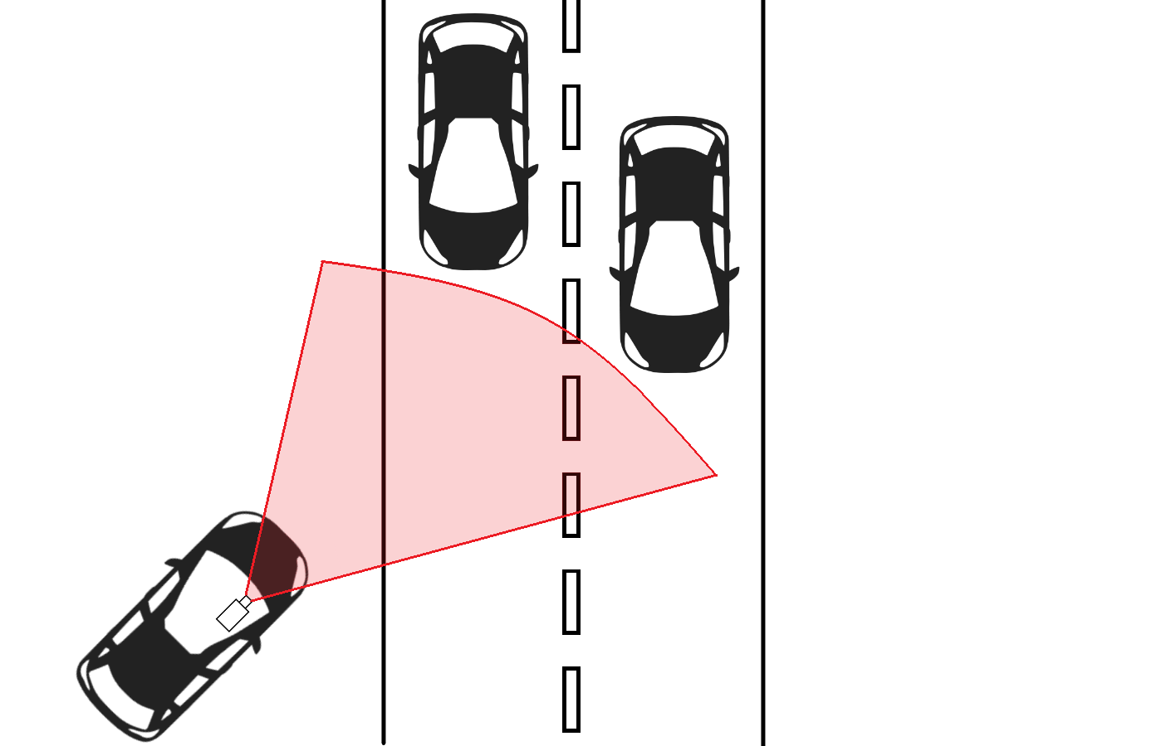
Figure 1 - Illustration of use case with max. 70º view angle is required - shooting from the off the road standpoint

Shooting during slow motion
For this use case max. 70º view angle is required. The mobile patrol vehicle moves slowly along parked cars and shoots their license plates. For this use case the mobile crew uses the rotating swivel to point to the desired direction towards parked cars.
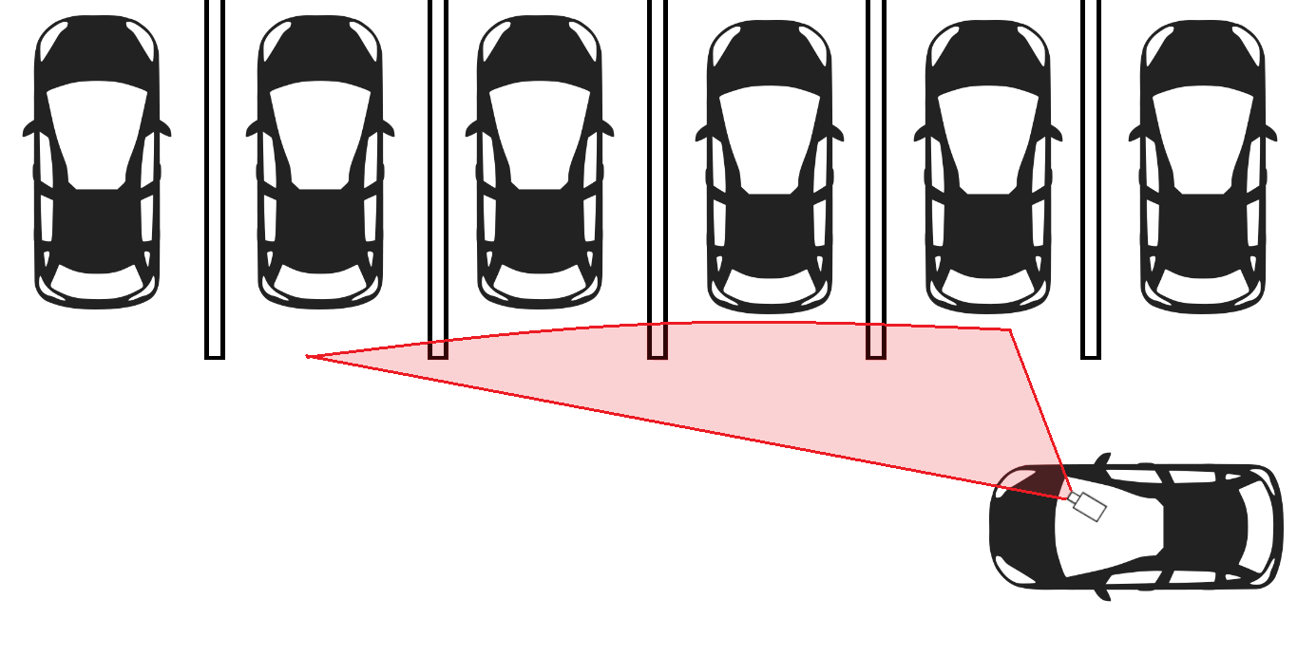
Figure 2 - Illustration of use case with max. 70º view angle - parking vehicles inspection

Shooting during fast motion
For this use case a min. 35º view angle is required. The mobile patrol vehicle follows the moving cars in front and takes video sequences with focus on the vehicle's license plate area.
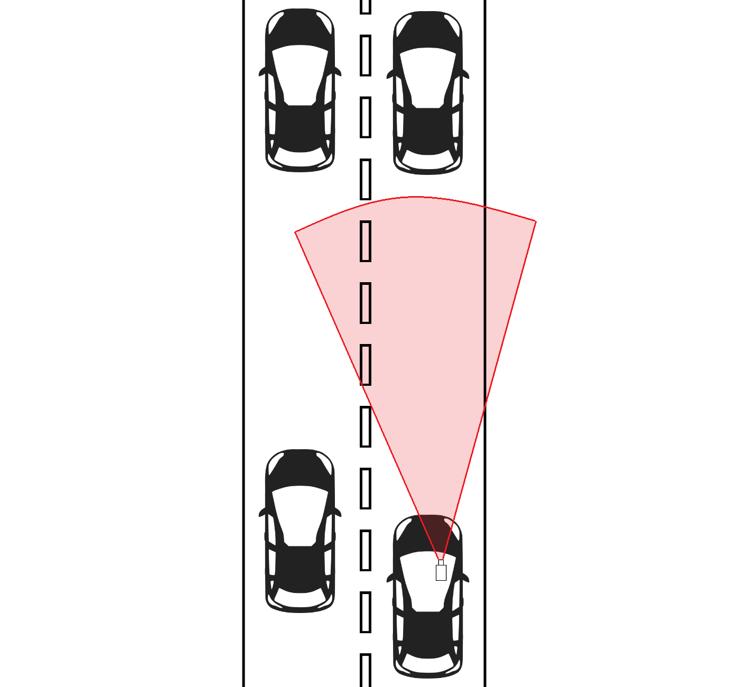
Figure 3 - Illustration of use case with min. 35º view angle is required - shooting during fast motion

Mandatory functional and technical parameters
The contracting authority requires that the offered cameras meet the following required mandatory technical parameters:
- transmitting video via RTSP protocol,
- frame rate equal or greater than 25 fps,
- size of the camera's optical sensor equal or greater than 1/2", due to the high demand of the contracting authority for image quality, high sensitivity to light (all use cases are without IR illumination) and desired low level of digital noise,
- variable focal length of the camera lens allowing to set the view angle range at minimum from 35º to 70º,
- automated control of the focal length via software interface,
- storage of at least two profiles of the focal length for various use cases (please refer to article 2),
- automatic presetting of the camera after selection of the profile stored,
- shock and vibration resistance, see also paragraph 1.3.
- PoE (Power over Ethernet) power supply.
The contracting authority furthermore requests that the offered cameras meet the following mandatory functional parameters:
- electronic image stabilization,
- autofocus,
- automatic white balancing,
- backlight compensation,
- noise reduction.

Warranty period

The contracting authority requires the supplier to provide a guarantee for the trouble-free operation of the equipment for at least 24 months.

The contracting authority requires the supplier to provide repair services for defective or damaged cameras in the form of exchange free of charge during the warranty period, i.e. the cost of such service must be included in the purchase price of the goods.

The length of the warranty period is one of the parameters of the tender evaluation. The maximum acceptable warranty period is 60 months from the date of delivery and receipt of the goods.

Leadtime

The contracting authority requires the supplier to deliver the requested goods no later than 90 days from the date of dispatch of the contracting authority's (client's) request for performance.

The supplier may offer a shorter leadtime, however.

The offered leadtime shall be subject to tender evaluation, while the contracting authority stipulates that the minimum delivery time is 10 days from the date of dispatch of the contracting authority (ordering party) for performance.

